

410448 & 410455: Project Work Book
(Guidelines and Log)
Fourth Year Computer Engineering
Year 2019 - 2020
Group/Project ID :
Team Members : 1…………………………………………………
2………………………………………………….
3…………………………………………………
4…………………………………………………
5…………………………………………………
Project Title :

Project Guide :
Area of the Project :
Sponsored/In house :
Name of the sponsoring organization: _______________________________

Name of the External Guide: ______________________________________
Phone Number: ________________ Email Id: _______________________

Department of Computer Engineering
Sinhgad Technical Education Society’s
SINHGAD COLLEGE OF ENGINEERING
Affiliated to Savitribai Phule Pune University, Pune

1


PROLOGUE

Project work is one of the most important components of the curriculum for the Engineering
Graduate. From conceiving the idea to the materialization of it is a journey that has to be
systematized, well defined and well documented to enjoy the full benefits of the efforts undertaken.
Every activity of the project development has its own importance and typical activities are like: Team formation, conceiving the idea, preparing the hypothesis, reporting the progress / development to the guide/ mentor, Interactions, suggestions and improvements, relevant documentations in proper format, schedule plans and visit logs.
Every institute is following their own best methods and techniques as per the guidelines
and curriculum at the affiliated university. To bring the uniformity and standardization for the
project work there is a need to come together and prepare the comprehensive guidelines regarding
it.
This work book for the project work will serve the purpose and facilitate the job of students, guide and project coordinator. This document will reflect accountability, punctuality, technical writing ability and work flow of the work undertaken.

This document will definitely support the work undertaken.

Dr. Varsha H Patil
Coordinator, BoS Computer Engineering
SPPU, Pune

2

GENERAL INSTRUCTIONS

1. Students should enter the correct information in the work book.
2. Get all entries verified by respective project guide. No changes are to be made without
project guide permission.
3. Students should report to their respective guides as per the schedule and its log is to be
maintained in the work book.
4. Follow all deadlines and submit all documents strictly as per prescribed formats.
5. The work book should be produced at the time of all discussions, presentations and
examinations.
6. The work book must be submitted to project coordinator/ guide/ department / College after
successful examination at the end of year.
7. All documents and reports are to be prepared in Latex only (All the formats specifications
provided adheres to MS Word but consequently applicable to final project report published
using Latex)
8. Submit hard as well as soft copy. Maintain one copy with each member.

3

PROGRAM EDUCATIONAL OBJECTIVES
1. To prepare globally competent graduates having strong fundamentals, domain knowledge,
updated with modern technology to provide the effective solutions for engineering problems.
2. To prepare the graduates to work as a committed professional with strong professional ethics
and values, sense of responsibilities, understanding of legal, safety, health, societal, cultural
and environmental issues.
3. To prepare committed and motivated graduates with research attitude, lifelong learning,
investigative approach, and multidisciplinary thinking.
4. To prepare the graduates with strong managerial and communication skills to work effectively
as individual as well as in teams.
PROGRAM OUTCOMES
Students are expected to know and be able -
1. To apply knowledge of mathematics, science, engineering fundamentals, problem solving
skills, algorithmic analysis and mathematical modeling to the solution of complex engineering
problems.
2. To analyze the problem by finding its domain and applying domain specific skills
3. To understand the design issues of the product/software and develop effective solutions with
appropriate consideration for public health and safety, cultural, societal, and environmental
considerations.
4. To find solutions of complex problems by conducting investigations applying suitable
techniques.
5. To adapt the usage of modern tools and recent software.
6. To contribute towards the society by understanding the impact of Engineering on global aspect.
7. To understand environment issues and design a sustainable system.
8. To understand and follow professional ethics.
9. To function effectively as an individual and as member or leader in diverse teams and
interdisciplinary settings.
10. To demonstrate effective communication at various levels.
11. To apply the knowledge of Computer Engineering for development of projects, and its finance
and management.
12. To keep in touch with current technologies and inculcate the practice of lifelong learning.

4


TABLE OF CONTENTS

Sr. No. Description Page No.
Prologue 2
General Instructions 3
Computer Engineering PEOs and POs 4
About Project work (Objectives and Outcomes, Guidelines
1 6
for Selection of Project Work and Evaluation)
2 Undertaking by Students 9
3 University Syllabus, PEO’s 10
4 Instruction Regarding Project Proposal and Finalization 12
5 Schedule of Project Work 13
Review for Semester I 14
6.1 Problem Statement, Motivation, Objectives and Literature
14
Review
6
6.2 Feasibility and Scope 15
6.3 Requirement Analysis 16
6.4 Design 17
7 Internal Evaluation Sheet for Semester I 18
Review Sheets for Semester II 19
8.1 Modeling 19
8 8.2 Coding and Implementation 20
8.3 Validation and Testing 21
8.4 Report Writing 22
9 Internal Evaluation Sheet for Semester II 23
10 Software Engineering code of ethics & professional practices 24
11 Contests Participation / Publications / IPR and Similar Event Record 27
12 Rubrics 28
BIBLIOGRAPHY 30

5

1. ABOUT PROJECT WORK
The word project comes from the Latin word projectum from the Latin verb proicere, "to throw something forwards" which in turn comes from pro-, which denotes something that precedes the action of the next part of the word in time (paralleling the Greek πρό) and iacere, "to throw". The word "project" thus actually originally meant "something that comes before anything else happens".
(Curtsey Ref- http://en.wikipedia.org/) The Project is conceiving the idea and
implementing it systematically by using the knowledge derived in the course of education mainly to innovate or facilitate.
Work involves, study the feasibility of the project, planning project, studying existing systems, tools available to implement the project and state of art software testing procedures and technology with use of case tools.
The group of Under Graduate students at Final Year students will undertake project over
the academic year. Work involves study the feasibility of the project, planning project,
studying existing systems, tools available to implement the project and state of art software
testing procedures and technology with use of case tools, design is to be implemented into
a working model (software or hardware or both) with necessary software interface as an
executable package.
a. Objectives and Outcomes:
Objectives -
• To Apply the knowledge for solving realistic problem To develop problem solving
ability
• To Organize, sustain and report on a substantial piece of team work over a period
of several months
• To Evaluate alternative approaches, and justify the use of selected tools and
methods,
• To Reflect upon the experience gained and lessons learned, To Consider relevant
social, ethical and legal issues,
• To find information for yourself from appropriate sources such as manuals, books,
research journals and from other sources, and in turn increase analytical skills.
• To Work in TEAM and learn professionalism.

6

Outcomes -
• Students are expected to know and be able to-
• Solve real life problems by applying knowledge.
• Analyze alternative approaches, apply and use most appropriate one for feasible
solution.
• Write precise reports and technical documents in a nutshell.
• Participate effectively in multi-disciplinary and heterogeneous teams exhibiting
team work, Inter-personal relationships, conflict management and leadership
quality.
b. Guidelines for Selection of Project Work:
Project is one of the significant contributory team works that has to be completed with
distinct impression. It is really very difficult to explore the domain of interest / research/
thirst area/ society need. In Toto one cannot figuratively define best project but still
there are certain parameters on which we can gauge the quality of project work done.
It will be better suited to go for well-defined and relatively safe projects that provide
scope for demonstrating proficiency with a low risk of failure especially at Under
Graduate level.

General guidelines:

• Identifying domain, feasibility and usability of work.
• Project work is expected to involve a combination of sound background
research (thorough study/ follow a line of investigation), and methodical
implementation.
• Instead of fancied and driven behind the gaudy and ostentatious ideas, the utility
has to be emphasized. It is also acceptable to identify the discrepancies/ flaws
in the existing system and work accordingly to rectify or improve.
• It is irrational to select the IDE and the software/ tools before the idea is not yet
finalized.
• Understanding the way project will be materialized and progressed.

7


c. Guidelines for Project Evaluation:
Project work is to be evaluated by both Internal and External examiners jointly, unanimously agreeing the following parameters among many others.

• Problem definition and scope of the project

• Through Literature Survey

• Appropriate Software Engineering approach

• Exhaustive and Rational Requirement Analysis
• Comprehensive Implementation- Design, platform, coding, documentation • Optimization considerations(Memory, time, Resources, Costing)
• Thorough Testing of all modules and integration of modules
• Project Presentation and Demonstration(User Interface, ease of use, usability) • Presentation of work in the form of Project Report(s)
• Understanding individual capacity, Role & involvement in the project
• Team Work (Distribution of work, intra-team communication and togetherness) • Participation in various contests, Publications and IPR
• Documents / Manuals(Project Report, Quick reference, System, Installation guide) • Outcomes / Usability / commercial value /product conversion of Work
(Refer Rubrics - page number 33)

8


3. UNDERTAKING BY STUDENTS

SINHGAD COLLEGE OF ENGINEERING, PUNE

UNDERTAKING BY STUDENT

We, the students of B.E. Computer hereby assure that we will follow all the rules and regulations related to project activity for the academic year 2017 -2018.The Project entitled-

will be fully designed/ developed by us and every part of the project will be original work and will not be copied/ purchased from any source.

Name of the student Signature

1.__________________________________

2.__________________________________

3.__________________________________

4.__________________________________

9

Savitribai Phule Pune University
Computer Engineering
Program Educational Objectives
PEO1. To prepare globally competent graduates having strong fundamentals, domain knowledge, updated with modern technology to provide the effective solutions for engineering problems.
PEO2. To prepare the graduates to work as a committed professional with strong professional ethics and values, sense of responsibilities, understanding of legal, safety, health, societal, cultural and environmental issues.
PEO3. To prepare committed and motivated graduates with research attitude, lifelong learning, investigative approach, and multidisciplinary thinking.
PEO4. To prepare the graduates with strong managerial and communication skills to work effectively an individual as well as in teams.
Program Outcomes
Students are expected to know and be able -
PO1. To apply knowledge of mathematics, science, engineering fundamentals, problem solving skills, algorithmic analysis and mathematical modeling to the solution of complex engineering problems.
PO2. To analyze the problem by finding its domain and applying domain specific skills
PO3. To understand the design issues of the product/software and develop effective solutions with
appropriate consideration for public health and safety, cultural, societal, and environmental considerations.
PO4. To find solutions of complex problems by conducting investigations applying suitable techniques. PO5. To adapt the usage of modern tools and recent software.
PO6. To contribute towards the society by understanding the impact of Engineering on global aspect. PO7. To understand environment issues and design a sustainable system.
10

PO7. To understand environment issues and design a sustainable system.
PO8. To understand and follow professional ethics.
PO9. To function effectively as an individual and as member or leader in diverse teams and interdisciplinary settings.
PO10. To demonstrate effective communication at various levels.
PO11. To apply the knowledge of Computer Engineering for development of projects, and its finance and management.
PO12. To keep in touch with current technologies and inculcate the practice of lifelong learning.
Program Specific Outcomes (PSO)
A graduate of the Computer Engineering Program will demonstrate-
PSO1: Professional Skills-The ability to understand, analyze and develop computer programs in the areas related to algorithms, system software, multimedia, web design, big data analytics, and networking for efficient design of computer-based systems of varying.
PSO2: Problem-Solving Skills- The ability to apply standard practices and strategies in software project development using open-ended programming environments to deliver a quality product for business success.
PSO3: Successful Career and Entrepreneurship- The ability to employ modern computer languages, environments, and platforms in creating innovative career paths to be an entrepreneur, and a zest for higher studies.

11

4. INSTRUCTIONS REGARDING PROJECT PROPOSAL AND
FINALIZATION:
1. The project work may involve the designing a system/subsystem or upgrading / improving
an existing system. The design is to be implemented into a working model (software or
hardware or both) with necessary software interface as an executable package (installable
package or hardware model) along with User & system manual and quick reference guide.
A project report including all necessary documents.
2. Group may come up with sponsored project. Sponsorship may not be in terms of money or
resources. It might be in terms of just suggesting problem definition and associated
guidance. Students may collect the letter required for applying the Institute/Industries for
the project sponsorship from project coordinator
3. List of suggested projects, prominent domains and respective expert , whom you may
contact for guidance, with Project Coordinator. Students may contact respective staff along
with synopsis for the guidance. Students may contact respective staff for projects suggested
by them in the respective areas.
4. Meet Project Coordinator for project title registration.
5. Synopsis must include project title, group members, sponsor details (if any), detailed
problem definition, area, abstract, details of existing similar systems if any, scope of the
project and software-hardware requirements. Sponsorship details include name of
sponsoring authority, address, name of guide, sponsorship terms & conditions and
respective documents certifying the same from authorities.
6. A Panel of experts will approve the project group and title only after presentation as per
schedule. Presentation will cover details mentioned in the synopsis as above.

12
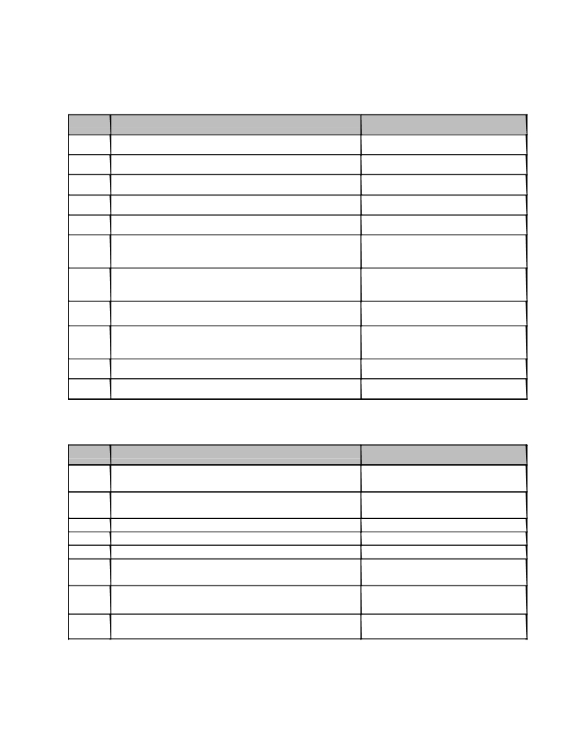

5. SCHEDULE OF PROJECT WORK
SEMESTER-I

Sr. No.
1
2
3
4
5
6.

7

8

9

10
11

Sr. No.

1

2
3
4
5
6.

7

8
Activity Scheduled Date
Registration of Project groups
Submission of Project Synopsis
Project presentations
Finalization of projects & allotment of guide Submission of final synopsis
First presentation about progress of project work (Review I)
Second presentation about progress of project work (Review II)
Third Presentation (Review III)
Fourth presentation about progress of project work (Review IV)
Submission of partial project report
Project work Examination

SEMESTER-II
Activity Scheduled Date
Fifth presentation about progress of project work
(Review V)
Sixth presentation about progress of project work
(Review VI)
Review of Publication Activity
Seventh presentation about progress of project Submission of Draft of Report for checking
Submission of final project report and Project Work
book to the project Coordinator
Mock Project Examination

Project Examination

13
Date
Mid of June
Last Week of June
First week of July
Second week of July
Third week of July
Last week of July

Third week of August

Second week of Sept

Last week of Sept

First Week of Oct
As per SPPU Notification

Date

Mid of Jan

Second week of Feb
Last Week of Feb
Second week of March
Third Week of March
Last Week of March
First Week of April
As per SPPU Notification

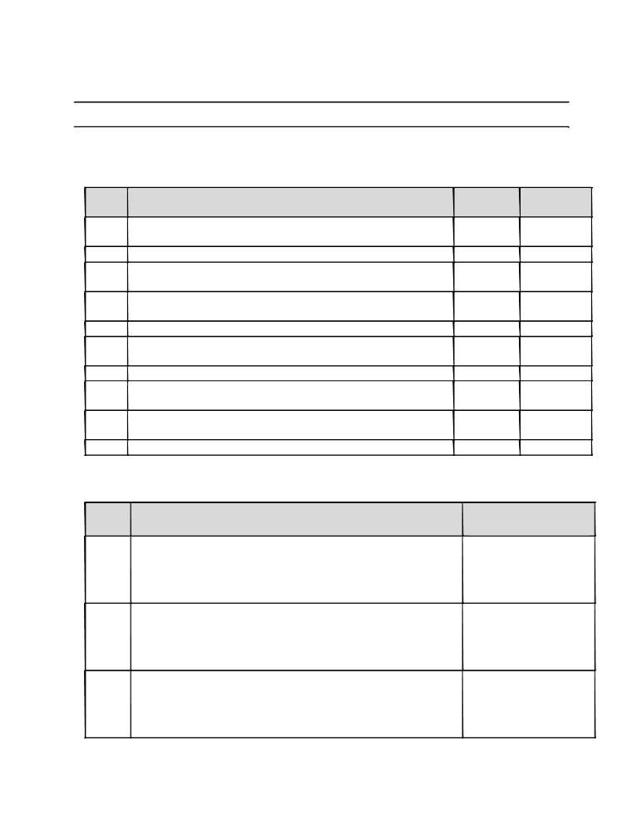

6.1 Project Review-I (Semester-I)
Problem Statement, Motivation, objectives and Literature Review: Students are expected to deliver presentation covering Problem Statement, Motivation, objectives and Literature Review.

Sr. No.

1.
2.
3.

4.
5.
6.
7.
8.

9.
10.
Questions Date
Does the statement gives clear identification about what project will accomplish?
Is the statement short and concise?
Can a person who is not familiar with the project understand scope of the project by reading the project problem statement? The project’s objectives of study (what product,
process, resource etc.) are being addressed?
Is similar type of methodology / model used for existing work? Is the studied literature sufficient to decide scope of the
project?
Are the objectives set will help to achieve goal of the project? Does Research gap identified will lead to find motivation of project?
Does your project contribute to our society by any means and will lead to find motivation?
Are the objectives clearly and unambiguously listed?
Sign of
Guide

Comments given by review committee members:

Sr.No. Comments By Review committee members :

1

2

3

14
Signature Review
committee Members

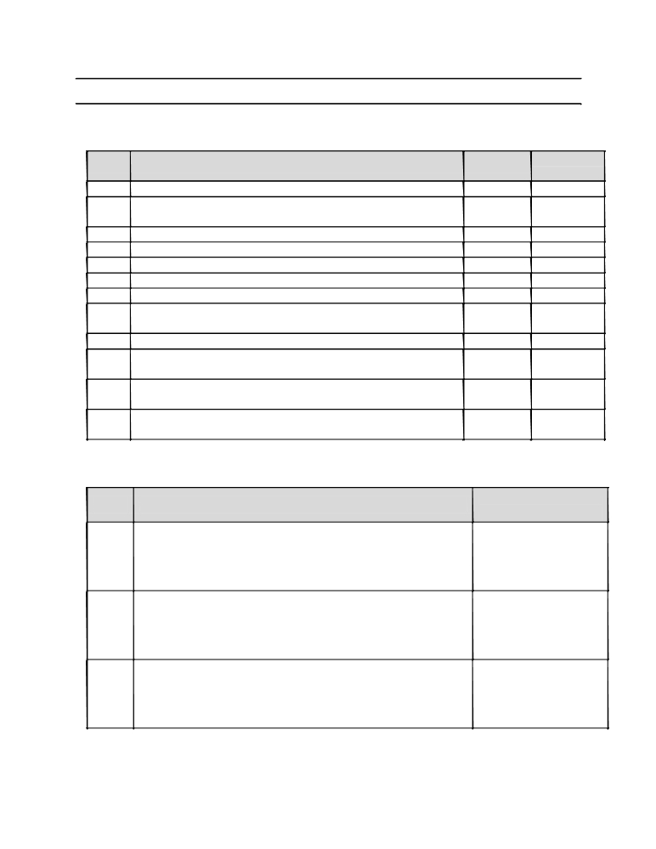

6.2 Project Review-II (Semester-I)

Feasibility and Scope: Students are expected to deliver presentation covering Feasibility and Scope

Sr. No.
1.
2.
3.
4.
5.
6.
7.
8.
9.
10.

11.

12.

Questions Date
Is the project’s view point is understood??
Is the project goal statement is in alignment with the
Sponsoring organization’s business goal and mission?
Who is the project’s end user?
What is the projected cost of producing a product?
Is project achievable in specified (Time, Cost Budget)?
Are the requirements within the scope of the project?
Is the scope properly defined?
Does the problem statement clearly define scope
of the project?
Do the project requirements fit into available hardware? Whether the milestones are stated completely and project timeline is given?
Whether risks like technical risks, Operational risks,
Schedule risks, business risks are identified correctly or not? Whether Risk prioritization is done properly or not and any back up plan is there or not?
Sign of
Guide

Comments given by review committee members:

Sr.No. Comments By Review committee members :

1

2

3

15
Signature Review
committee Members

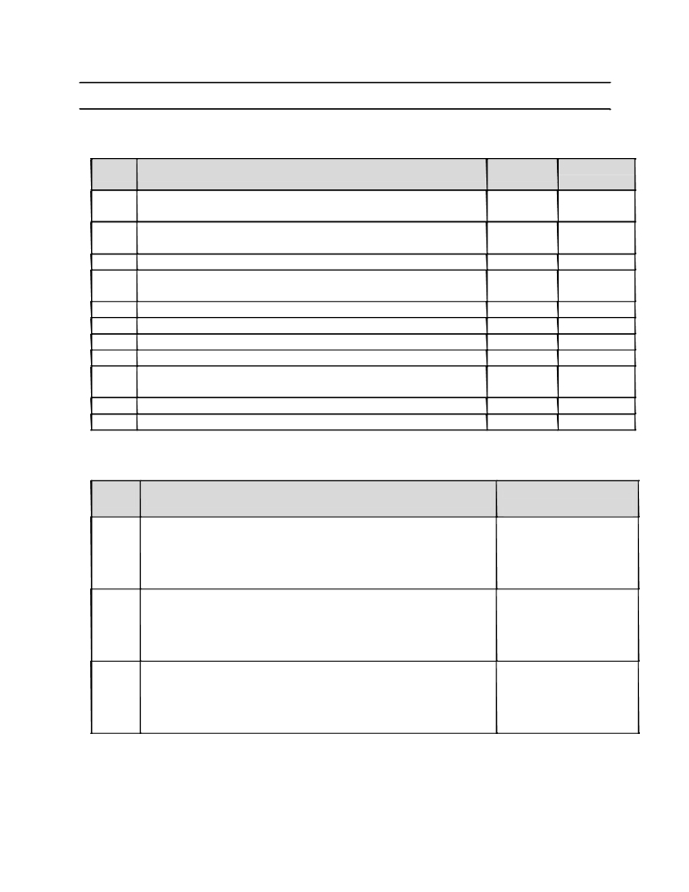

6.3 Project Review-III (Semester-I)

Requirement Analysis: Students are expected to deliver presentation covering Requirement Analysis.

Sr. No.

1.

2.
3.
4.
5.
6.
7.
8.
9.
10.
11.

Questions Date
Is information domain analysis complete, consistent and accurate?
Is problem statement categorized in identified area and
targeted towards specific area there in?
Is external and internal interfacing properly defined?
Are requirement consistent with schedule, resources and budget?
Are all requirements traceable to system level?
What is needed to make the product?
Is there a demand for the produce?
Is identification of stakeholders is done properly?
Whether all requirements are captured and documented in line with scope?
Whether all type of analysis classes are identified or not? Whether the Acceptance criteria is decided are not?
Sign of
Guide

Comments given by review committee members:

Sr.No. Comments By Review committee members :

1

2

3

16
Signature Review
committee Members



6.4 Project Review-IV (Semester-I)

Design: Students are expected to deliver presentation covering Design.

Sr. No.
1.
2.
3.
4.
5.
6.

7.
8.
9.
10.
11.
12.
13.
14.
15.
16.

17.
Questions Date
Are requirement reflected in the system architecture?
Does the design support both project (product) and project goals? Does the design address all the issues form the requirement?
Is effective modularity achieved and modules are functionally
independent?
Are structural diagrams (class, Object, etc) are well defined? Are all class associations clearly defined and understood?(Is it cleat which classes provide which services)?
Are the classes in the class diagram clear? (What they represent in the architecture design document?)
Is inheritance appropriately used?
Are the multiplicities in the use case diagram depicted in the class diagram?
Are all objects used in sequence diagram?
Are the symbols used in all diagrams corresponding to UML standards? Are behavioral diagrams (use case, sequence, activity, etc.) well defined and understood?
Does each case have clearly defined actors and input/ output? Does the sequence diagram matches with class diagram?
Is aggregation/ containment (used) clearly defined and understood? Whether State charts are capturing system’s dynamic behavior correctly or not?
Related to procedural thinking whether DFDs and CFDs along with transaction and transformation flow are done correctly or not?
Sign of
Guide

Comments given by review committee members:

Sr.No. Comments By Review committee members :

1

2

3

17
Signature Review
committee Members

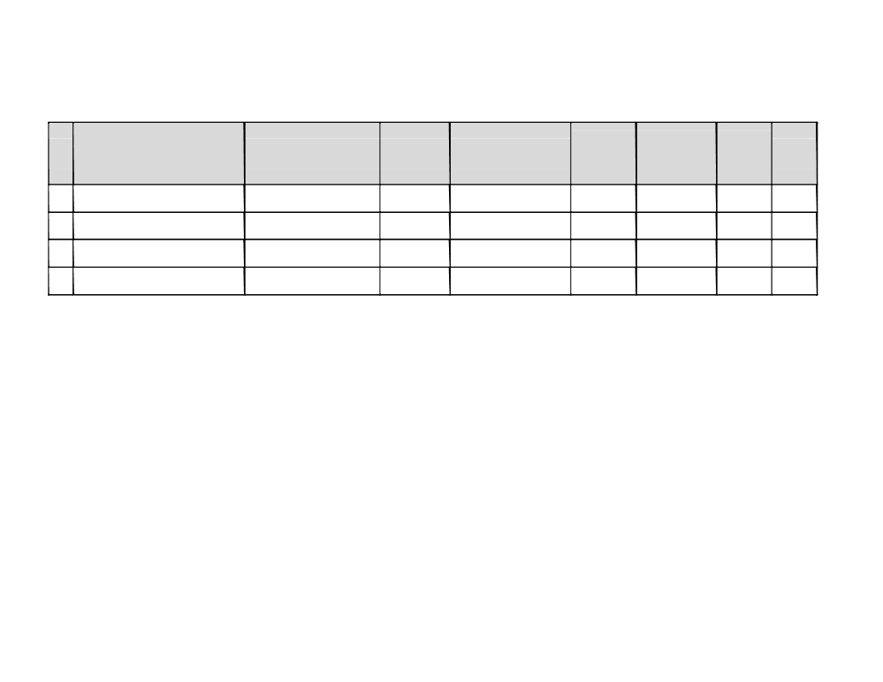

7. INTERNAL EVALUATION SHEET (SEMESTER I)

Sr.
No.

Name of Student

Problem
Stmt./Motivation/Obje ctives/Scope/Feasibility
Requirements (05)

Requirement
Lit. Survey Analysis (05)
(05) Modelling & design
(10)

Planning Presentation,
Prototype Q & A
(05) (10)

Project
Total
Report
(50)
(10)

Name and Signature of Evaluation Committee:
1. Prof. _______________________________________

2. Prof. _______________________________________

3. Prof. _______________________________________

Comments by External Examiner:

Name & Signature of External Examiner Name & Signature of Guide Signature of HoD

18

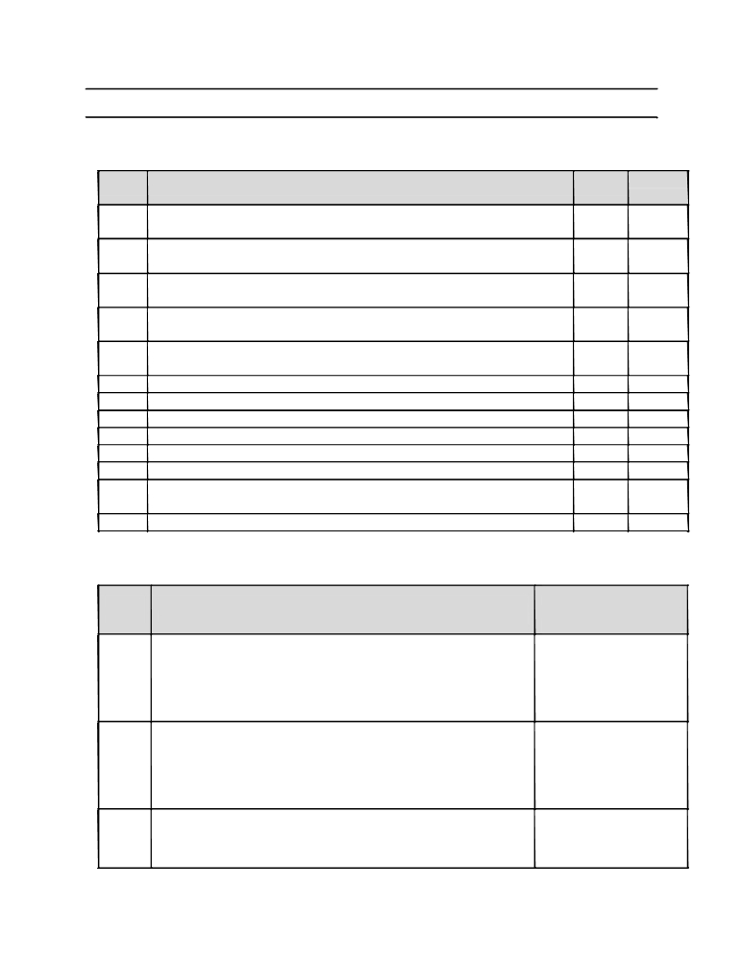

8.1 Project Review-I (Semester-II)

Modeling (Model Refinement and Algorithm development) : Student is expected to deliver presentation covering Modeling

Sr. No.

1.

2.

3.

4.

5.
6.
7.
8.
9.
10.
11.
12.
13.

Questions Date
Which software Development Process model is used? (Water fall, Incremental, RAD) How? ( at this level?)
Do you clearly identify data objects, their attributes and relationships? (All constraints from SRS are captured or not?)
Have you clearly matched the objects with respective classes and their responsibilities?
Have you analyzed the requirements and represented them into respective models?
Can you differentiate between different system states and depict them in the form of state transition diagram?
Does the mathematical model clearly imply design of the project? Does the mathematical model clearly states goal of project? Does the interface between the modules properly identified? Does any functional dependencies are identified and described? Which architectural model does your system supports?
Whether Deployment diagram is in line with selected architecture? Whether all components are designed properly and represented in component diagram?
Whether NP-completeness of algorithms is checked or not?
Sign of
Guide

Comments given by review committee members:

Sr.No. Comments By Review committee members :

1

2

3

19

Signature Review
committee Members

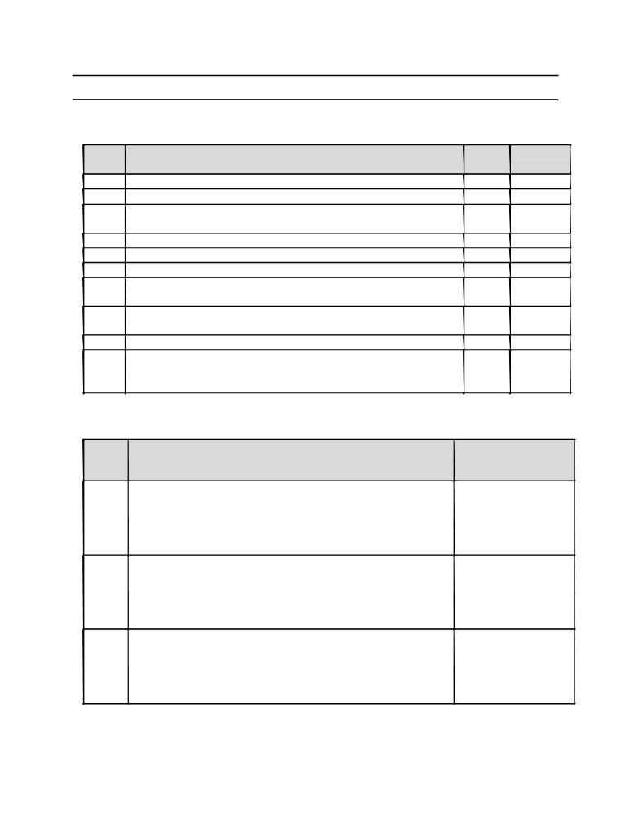

8.2 Project Review-II (Semester-II)

Coding / Implementation: Student is expected to deliver presentation covering Coding / Implementation.

Sr. No.
1.
2.
3.
4.
5.
6.
7.

8.
9.

10.

Questions Date
Does the code completely and correctly implement the design? Does the code comply with the coding standard?
Is the code well structured, consistent in style, and consistently formatted?
Are all functions in the design coded?
Does the code make use of object oriented concepts?
Does the code support granularity?
Does the language used for coding is correctly chosen as per the project need?
If any off the shelf components are used, Have you understood the functionalities of using it?
Are all comments consistent with the code?
Whether code optimization is done properly or not?(By using language
features)
Sign of
Guide

Comments given by review committee members:

Sr.No. Comments By Review committee members :

1

2

3

20

Signature Review
committee Members

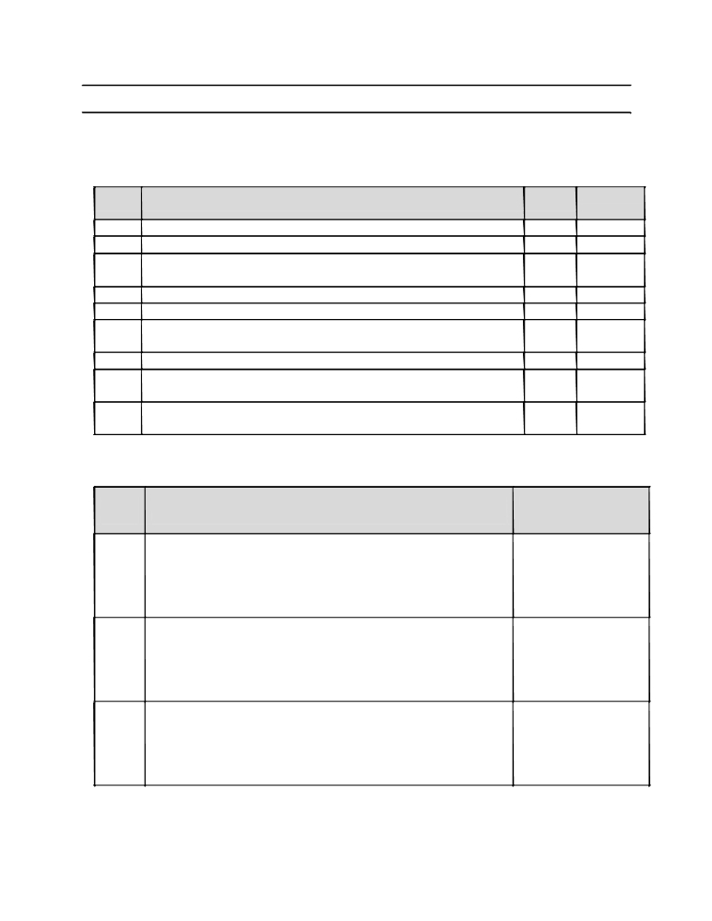

8.3 Project Review-III (Semester-II)

Validation and Testing: Student is expected to deliver presentation covering Validation and Testing

Sr. No.
1.
2.
3.
4.
5.
6.
7.
8.

9.

Questions Date
Have you done alpha testing?
Have you done beta testing?
Have you validated the requirements, design and code as per standard?
Have you performed GUI testing of project? How?
Does your system comply with basic usability norms?
Have you tested the code using standard datasets available in your area of project?
Have you tested the code in real time environment?
After integration of all components whether total performance of system is checked or not?
Whether repository of all components along with versions is documented or not?

Sign of
Guide

Comments given by review committee members:

Sr.No. Comments By Review committee members :

1

2

3

21
Signature Review
committee Members

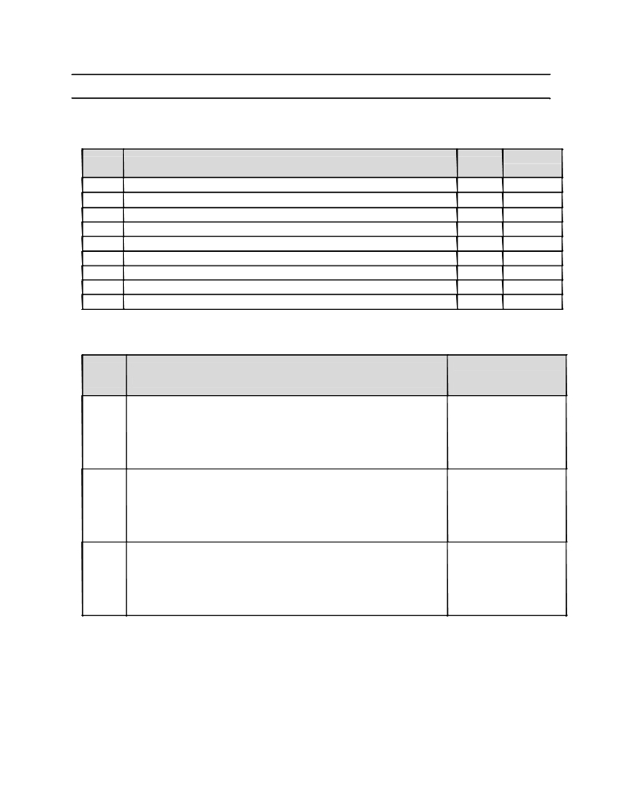

8.4 Project Review-IV (Semester-II)

Report Writing: Student is expected to deliver presentation covering Report Writing

Sr. No. Questions Date
1. Is the report written as per the prescribed format?
2. Is the report timely prepared?
3. Is the report properly organized, spelled, grammatically correct?
4. Is the report plagiarism free?
5. Is the report precise and written to the point?
6. Is the report contains complete results and comparative graphs?
7. Are all figures and tables properly numbered and labeled?
8. Are all figures and tables properly cited?
9. Whether references are properly cited?

Comments given by review committee members:

Sign of
Guide

Sr.No. Comments By Review committee members :

1

2

3

22

Signature Review
committee Members

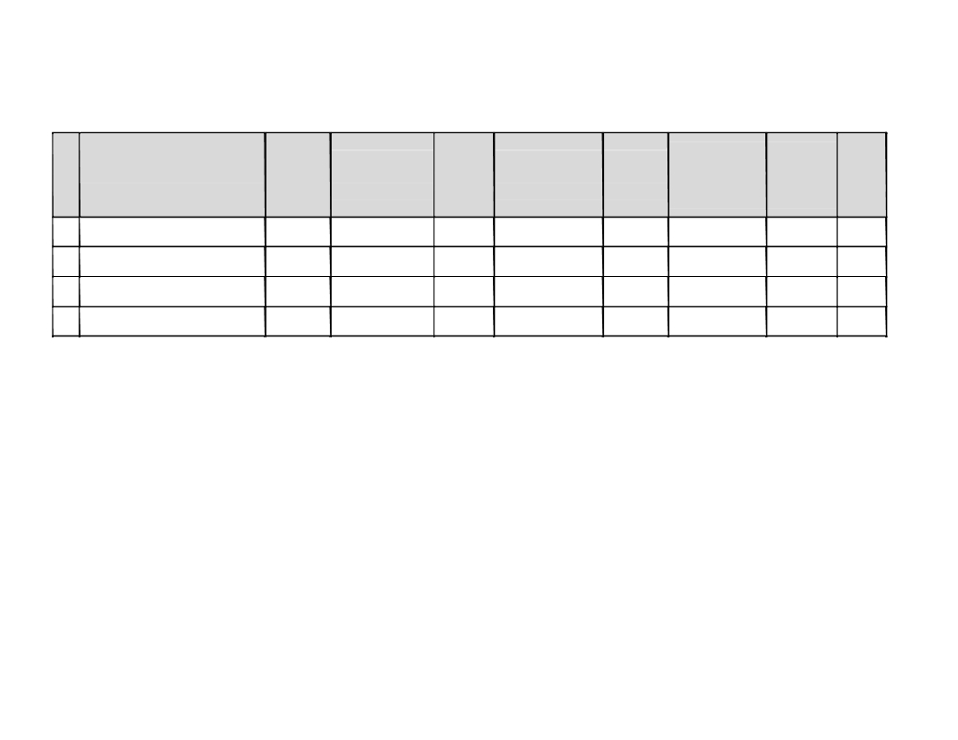

9. INTERNAL EVALUATION SHEET (SEMESTER II)

Sr.
No.

Name of Student

Modeling
(10)

Coding &
Implementation
(40)

Understanding,
Individual Team
Testing Involvement,
Contribution in Work
(10) Project (10)
(10)

Demonstration Documents
& & Total
Presentation Report (100)
(10) (10)

Name and Signature of Evaluation Committee:
1. Prof. _______________________________________

2. Prof. _______________________________________

3. Prof. _______________________________________

Comments by External Examiner:

Name & Signature of External Examiner Name & Signature of Guide Signature of HoD

23

10. SOFTWARE ENGINEERING CODE OF ETHICS AND
PROFESSIONAL PRACTICES
(Courtesy / Reference- http://www.acm.org/about/code-of-ethics )
Computers have a central and growing role in commerce, industry, government, medicine,
education, entertainment and society at large. Software engineers are those who contribute by
direct participation or by teaching, to the analysis, specification, design, development,
certification, maintenance and testing of software systems. Because of their roles in developing
software systems, software engineers have significant opportunities to do good or cause harm, to
enable others to do good or cause harm, or to influence others to do good or cause harm. To ensure,
as much as possible, that their efforts will be used for good, software engineers must commit
themselves to making software engineering a beneficial and respected profession. In accordance
with that commitment, software engineers shall adhere to the following Code of Ethics and
Professional Practice.
The Code contains eight Principles related to the behavior of and decisions made by professional
software engineers, including practitioners, educators, managers, supervisors and policy makers,
as well as trainees and students of the profession. The Principles identify the ethically responsible
relationships in which individuals, groups, and organizations participate and the primary
obligations within these relationships. The Clauses of each Principle are illustrations of some of
the obligations included in these relationships. These obligations are founded in the software
engineer’s humanity, in special care owed to people affected by the work of software engineers,
and the unique elements of the practice of software engineering. The Code prescribes these as
obligations of anyone claiming to be or aspiring to be a software engineer.
Software engineers shall commit themselves to making the analysis, specification, design, development, testing and maintenance of software a beneficial and respected profession. In accordance with their commitment to the health, safety and welfare of the public, software engineers shall adhere to the following Eight Principles:
1. PUBLIC - Software engineers shall act consistently with the public interest.
2. CLIENT AND EMPLOYER - Software engineers shall act in a manner that is in the best
interests of their client and employer consistent with the public interest.

24

3. PRODUCT - Software engineers shall ensure that their products and related modifications
meet the highest professional standards possible.
4. JUDGMENT - Software engineers shall maintain integrity and independence in their
professional judgment.
5. MANAGEMENT - Software engineering managers and leaders shall subscribe to and promote
an ethical approach to the management of software development and maintenance.
6. PROFESSION - Software engineers shall advance the integrity and reputation of the
profession consistent with the public interest.
7. COLLEAGUES - Software engineers shall be fair to and supportive of their colleagues.
8. SELF - Software engineers shall participate in lifelong learning regarding the practice of their
profession and shall promote an ethical approach to the practice of the profession.

Environment and Computing:
Information and communication technologies (ICTs ) have been contributing to environmental
problems: computers, electronic devices and ICT infrastructure consume significant amounts of
lectricity, placing a heavy burden on our electric grids and contributing to greenhouse gas
emissions. In 2007, the total footprint of the ICT sector - including personal computers (PCs) and
peripherals, telecoms networks and devices and data centers - was 830 Mt CO2 emission, about
2% of the estimated total emissions from human activity released that year (a figure equivalent to
aviation ). ICT hardware poses severe environmental problems both during its production and its
disposal. Each stage of a computer’s life, from its production, throughout its use, and into its
disposal, presents environmental problems. Manufacturing computers and their various electronic
and non electronic components consumes electricity, raw materials, chemicals, and water , and
generates hazardous waste. All these directly or indirectly increase carbon dioxide emissions and
impact the environment and the trend is to increase in the BAU ( Business As Usual ) scenario.

Green Computing:
Hence you all our students are requested to follow green computing practices. Green computing is
the study and practice of designing, manufacturing, using, and disposing of computers, servers,
and associated subsystems — such as monitors, printers, storage devices, and networking and
communications systems —efficiently and effectively with minimal or no impact on the
environment. Green computing includes the dimensions of environmental sustainability, the
25

economics of energy efficiency, and the total cost of ownership, which includes the cost of disposal and recycling. Green computing benefits the environment by improving energy efficiency, lowering greenhouse gas emissions, using less harmful materials, and encouraging reuse and recycling . Green design, Green manufacturing, Green use, Green disposal are complementary paths of green ICT. Only focusing on these four fronts we can achieve total environmental sustainability from the IT side and make IT greener throughout its entire lifecycle.

Social Life and Computing:
Each IT professional must keep in mind the three key components of a corporate Green IT best practices policy -Environment, Economy and Social aspect. The invention of the computer has completely changed the way we live our lives. Nearly everything is controlled by a computer; cars, satellites, phones, etc. Computers have made our lives easier. Computers can also have positive effects on a person's social life when their power to connect over great distances is harnessed fully. Computers have both positive and negative impact in our society. While technology is a wonderful thing it is almost likely that it can be used in an immoral or wrong way. There is a price to pay for everything even if it appears it's making life easier on people.
While proper lifecycle management can greatly boost a IT company's ecological and
environmental sustainability position, it can also contribute to achieving goals on the social front.
Hardware retirement practices are the primary concern in this regard. In addition to seeking carbon
neutrality, a proper asset retirement strategy should seek sustainability in the communities where
companies operate.

The following social objectives should be considered:
1. To optimize sustainability in their IT infrastructure, companies should focus on each state of
the IT lifecycle
2. Setting the Appropriate Corporate Sustainability Policy
3. Avoiding unethical labor practices and Controlling unethical exports
4. Accountability in the Recycling e-waste and Sustainability Metrics and Reporting
5. Greater Transparency Regarding Material Analysis and Extraction
6. Compliance with stringent, evolving security regulations

26
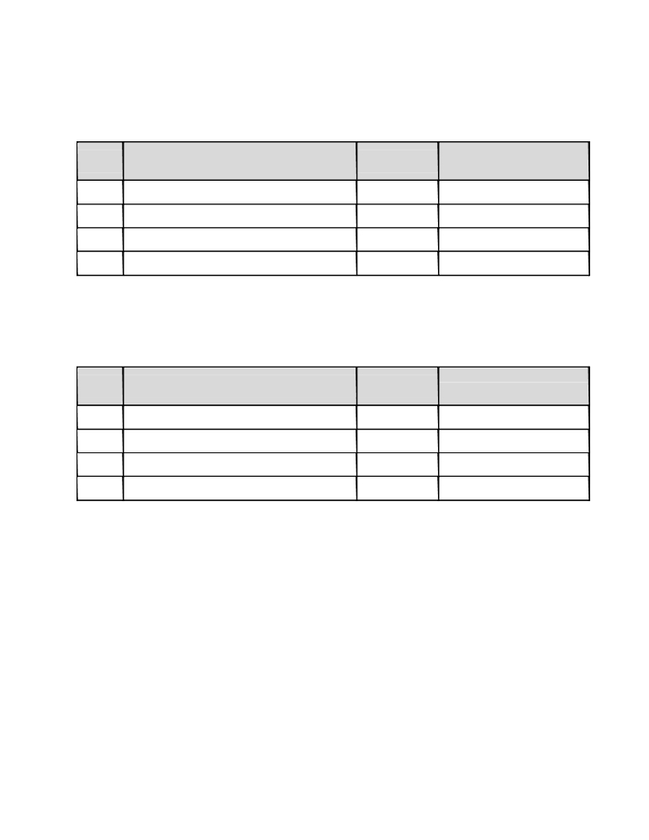

11. CONTEST PARTICIPATION DETAILS

A. Participation in project Competition / Contest:

Sr. No. ^{Name and Place of Project} Competition
and Exhibition
1.
2.
3.
4.
Attach attested copy of certificate(s)

B. Paper Publication / Presentation/ IPR :

Sr. No. Name of Organizer

1.
2.
3.
4.

27

Date

Date

Certificates/ Prizes won if
any

Certificates / Prizes won if
any

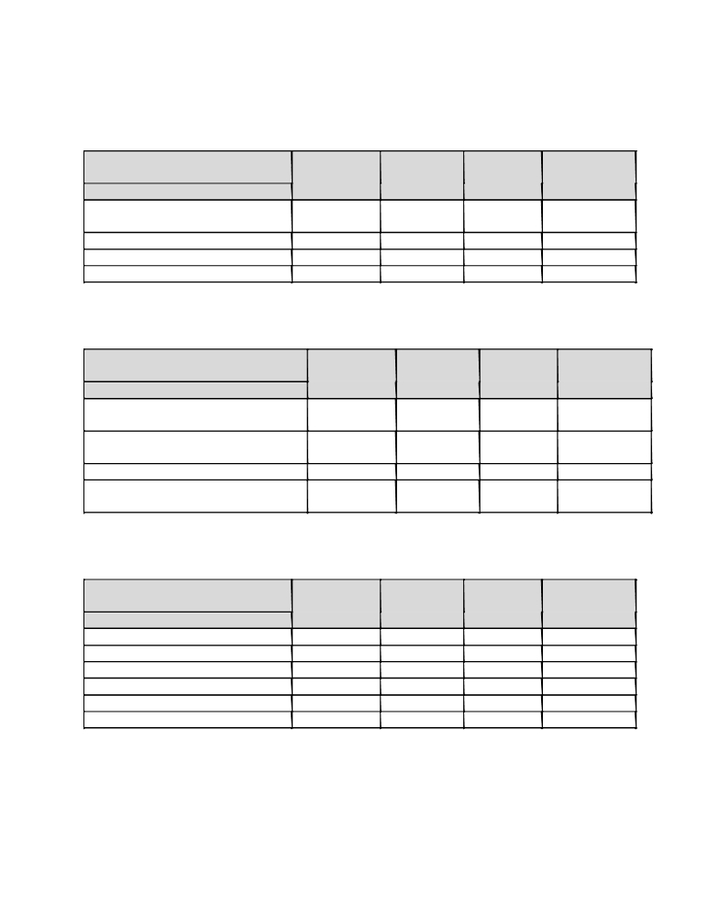

12. RUBRICS

A. IDEA Conception

Grade Excellent Very Good Fair Poor
(Grade Point) (10-9) (6-8) (3-5) (1-2)
Parameter
Problem Definition and Scope of
the Project
Literature Survey
Software Engineering Approach
Requirement Analysis

B. Implementation

Grade Excellent Very Good Fair Poor
(Grade Point) (10-9) (6-8) (3-5) (1-2)
Parameter
Implementation- Design, platform,
coding,
Optimization considerations
(Memory, time, Resources, Costing)
Thorough Testing of all modules
Integration of modules and project
as whole

C. Documents

Grade Excellent Very Good Fair Poor
(Grade Point) (10-9) (6-8) (3-5) (1-2)
Parameter
Synopsis
Project Report
Quick references
System manual
Installation Guide
Work Book

28
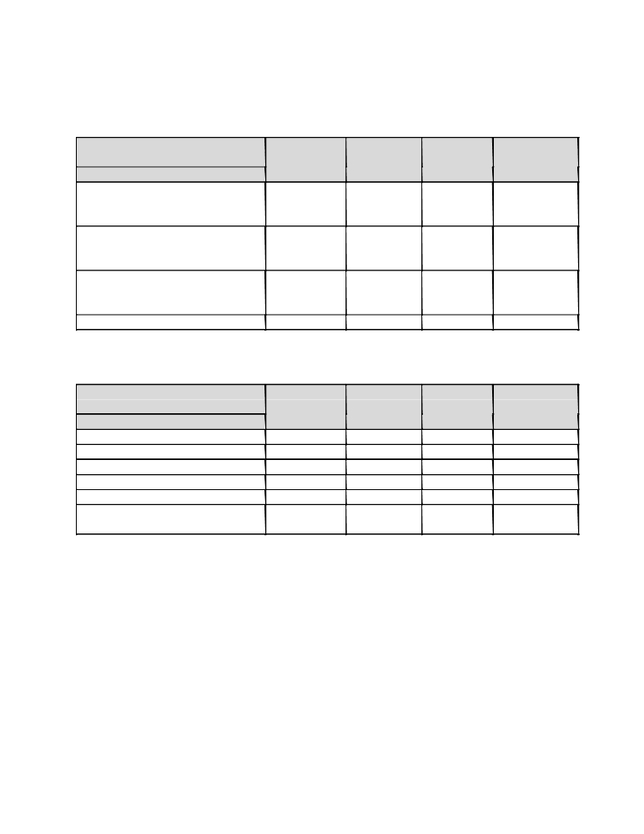

D. Demonstration

Grade Excellent Very Good Fair Poor
(Grade Point) (10-9) (6-8) (3-5) (1-2)
Parameter
Project Presentation and
Demonstration(User Interface,
ease of use, usability)
Understanding individual
capacity & involvement in the
Project
Team Work (Distribution of
work, intra-team communication
and togetherness)
Outcomes / Usability

A. Contest Participation / Awards, Publications and IPR

Grade Excellent Very Good Fair Poor
(Grade Point) (10-9) (6-8) (3-5) (1-2)
Parameter
Participation in various contests
Appreciation and Awards
Publications
Copyright
Patent
Commercial value /product
conversion of Work

29

BIBLIOGRAPHY
1. Roger S. Pressman, “Software Engineering: A Practitioner’s Approach”, 6th Edition McGrawHill, ISBN978-0-07-337597-7.
2. Joseph Phillips, “IT Project Management”, Tata McGraw-Hill 2003 Edition, ISBN 13: 978-
0071700436
3. www.csc.villanova.edu/~tway/courses/csc4181/s2010/srs_template-1.doc
4. http://unipune.ac.in/Syllabi_PDF/revised-2015/engineering/BE-Computer-2012-course-27-8-
15.pdf

30

